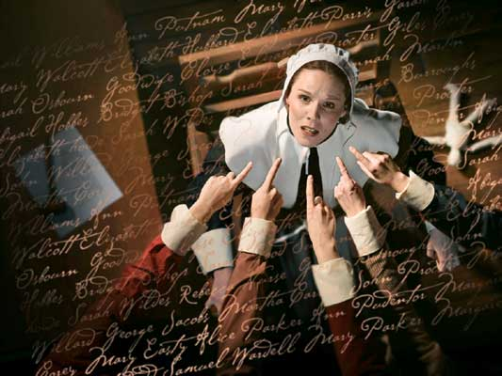
The Crucible
Webquest

Use the links on the website to access the supplemental marterial for each of the following prompts.
- McCarthyism
Give a full description defining McCarthyism and the Red Scare. Who was McCarthy? What happened in Hollywood during this time? What is the legacy of McCarthy? 200-300 words.

- Interview/Second Article
Read an article and interview with Linnda Caporael. Consider information in the second article on the trials. What do you think of Caporael's theories? Can they adequately explain the hysteria in Salem. What other forces could have been at work? 600 words.

- Complete Online
- Response
George Santayana said, "Those who cannot learn from history are doomed to repeat it." What does this quote mean? How do we keep repeating history? How do we learn from it? Describe how successful you think The Crucible is on educating its readers about history. 400-500 words.

