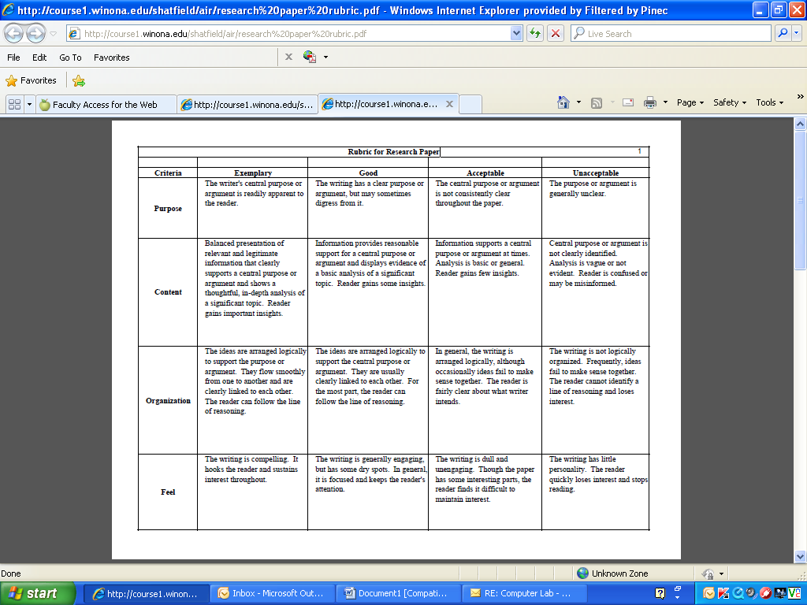

3

2

1

0

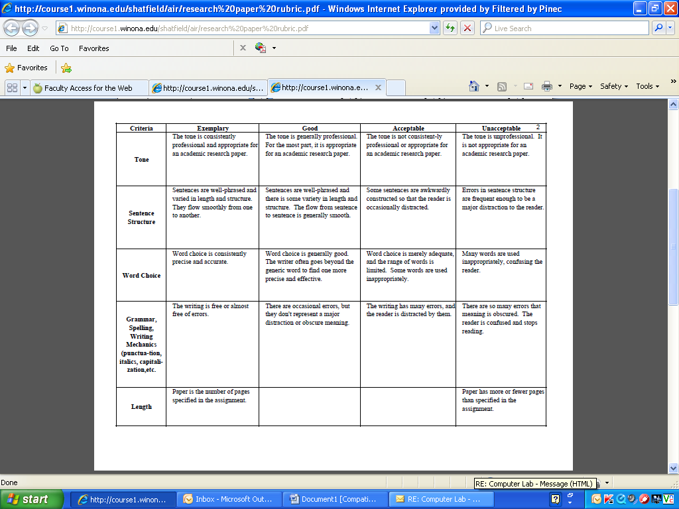

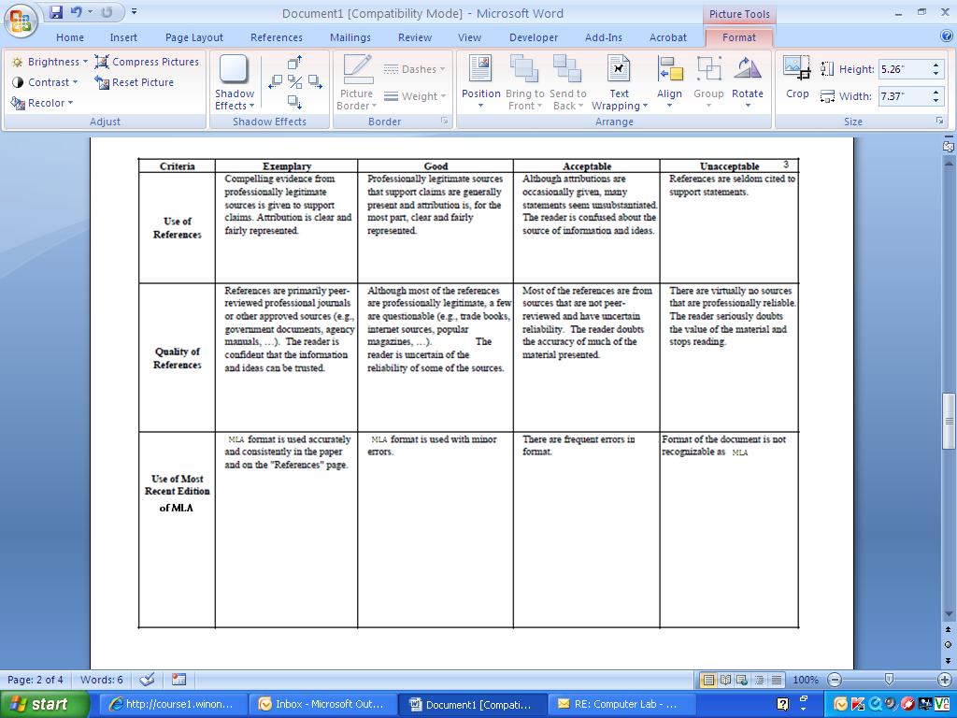

Name______________________________________________

Grade______/36 = ______%

Additional Comments: