REQUIREMENTS FOR RESEARCH PAPER

The following information is the criteria upon which your papers will be graded. It is not a
series of suggestions. This document should be followed explicitly. If you have questions, ask before you turn in your paper.

1. Choose a topic of interest to you and then narrow it so you can completely cover your
subject within the page requirement of 6-7 pages. (Do not exceed the page requirements
because you will lose points. Your skill at conforming to exact requirements is a vital
one. In real life your work often must comply with requirements of length, often an
exact number of words and format.) If you need help with this, just ask.

2. As a general rule you should consult twice as many sources as the number of pages
required for the paper. More or less than two is acceptable as long as the topic is covered
thoroughly. You will be required to have 8+ sources.

3. You are responsible for knowing the accuracy and reliability of your sources. This is true
whether the information comes from a printed source, an interview, or the internet. In
other words, find out whether the author is qualified to write an accurate account.
Whenever possible use primary sources – firsthand or eyewitness documents – rather
than secondary sources – scholarly works written by reputable historians after the event.
Regardless of whether it is a primary or secondary source you must evaluate the
information and interpretations presented for veracity and appropriateness. You may
find information about an author in the introduction of his work. (Do not use textbooks, popular magazines, dictionaries, or encyclopedias.)

RESEARCH QUESTION
Due: Wednesday, November 15

What is a research question?
A research question is a clear, focused, concise, complex and arguable question around which you center your research. You should ask a question about an issue that you are genuinely curious about.
Why is a research question essential to the research process?
Research questions help writers focus their research by providing a path through the research and writing process. The specificity of a well-developed research question helps writers avoid the “all-about” paper and work toward supporting a specific, arguable thesis.
Steps to developing a research question:
Choose an interesting general topic. Even directed academic research should focus on a topic in which the writer is at least somewhat personally invested. Writers should choose a broad topic about which they genuinely would like to know more. An example of a general topic might be “Slavery in the American South” or “Films of the 1930s.”

Do some preliminary research on your general topic. Do a few quick searches in current periodicals and journals on your topic to see what’s already been done and to help you narrow your focus. What questions does this early research raise?

Start asking questions. Taking into consideration all of the above, start asking yourself open-ended “how” and “why” questions about your general topic. For example, “How did the slave trade evolve in the 1850s in the American South?” or “Why were slave narratives effective tools in working toward the abolishment of slavery?”
Evaluate your question.
Is your research question clear?
With so much research available on any given topic, research questions must be as clear as possible in
order to be effective in helping the writer direct his or her research.
Is your research question focused?
Research questions must be specific enough to be well covered in the space available. (See the following page for examples of focused vs. unfocused research questions.)
Is your research question complex?
Research questions should not be answerable with a simple “yes” or “no” or by easily-found facts. They should, instead, require both research and analysis on the part of the writer.
Hypothesize.
After you’ve come up with a question, think about what the path you think the answer will take. Where do you think your research will take you? What kind of argument are you hoping to make/support? What will it mean if your research disputes your planned argument?

Sample Research Questions

Unclear: Why are social networking sites harmful?
Clear: How are online users experiencing or addressing privacy issues on such social networking sites as MySpace and Facebook?

The unclear version of this question doesn’t specify which social networking sites or suggest what kind of harm the sites are causing. It also assumes that this “harm” is proven and/or accepted. The clearer version specifies sites (MySpace and Facebook), the type of harm (privacy issues), and who the issue is harming (users). A strong research question should never leave room for ambiguity or interpretation.
Unfocused: What is the effect on the environment from global warming?
Focused: How is glacial melting affecting penguins in Antarctica?
The unfocused research question is so broad that it couldn’t be adequately answered in a book-length piece, let alone a standard high school level paper. The focused version narrows down to a specific cause (glacial melting), a specific place (Antarctica), and a specific group that is affected (penguins). When in doubt, make a research question as narrow and focused as possible.

Too simple: How are doctors addressing diabetes in the U.S.?
Appropriately Complex: What are common traits of those suffering from diabetes in America, and how can these commonalities be used to aid the medical community in prevention of the disease?
The simple version of this question can be looked up online and answered in a few factual sentences; it leaves no room for analysis. The more complex version is written in two parts; it is thought provoking and requires both significant investigation and evaluation from the writer. As a general rule of thumb, if a quick Google search can answer a research question, it’s likely not very effective.

ANNOTATED BIBLIOGRAPHY
Due: Wednesday, November 28

You must have 8+ sources for this paper.

3-4 of these sources must be non-electronic resources (books, periodicals, interviews, journals etc.)
A bibliography is a list of sources (books, journals, websites, periodicals, etc.) one has used for researching a topic. In the MLA format, a bibliography is called a Works Cited page. A bibliography usually just includes the bibliographic information (i.e., the author, title, publisher, etc.).
An annotation is a summary and/or evaluation.
Therefore, an annotated bibliography includes a summary and/or evaluation of each of the sources. Depending on your project or the assignment, your annotations may do one or more of the following:
- Summarize: Some annotations merely summarize the source. What are the main arguments? What is the point of this book or article? What topics are covered? If someone asked what this article/book is about, what would you say?
- Assess: After summarizing a source, it may be helpful to evaluate it. Is it a useful source? How does it compare with other sources in your bibliography? Is the information reliable? Is this source biased or objective? What is the goal of this source?
- Reflect: Once you've summarized and assessed a source, you need to ask how it fits into your research. Was this source helpful to you? How does it help you shape your argument? How can you use this source in your research project? Has it changed how you think about your topic?
The annotation for each source should be 4-7 sentences.

USE PROPER MLA FORMATING FOR YOUR WORKS CITED PAGE.
See http://owl.english.purdue.edu/owl/ if you need help with this.

Example:

Smith, Wayne. “Pennsylvania and the American Civil War: Recent Trends and Interpretations”.
Pennsylvania History 51, no. 3 (1984): 206-231.

In this article, Smith addresses the fact that as the practice of studying of history has changed
and evolved in the past 20 years, it has presented us with fresh perspectives on the Civil War,
particularly with in Pennsylvania. Smith argues that new information and interpretation has had a
notable impact on our understanding of the Civil War and has changed Pennsylvania historian’s
intellectual insights. After addressing how interpretations of Pennsylvania’s Civil war history
and changed, Smith concludes by stating that it is history which determines our present trends
and attitudes. However, contemporary “intellectual and social changes” have caused us to raise
new questions and attitudes on Civil War history and fact. This source is reliable because Mr. Smith is a professor of Civil War history at Yale. This would be a useful source for my research paper because it helps to give a more modern view on the immediate effects of the war.

OUTLINE
Due: Wednesday, November 28

Use the outlining format (proper numbering and lettering) that Ms. Berry gave you on the writing handout.

It is up to you to determine how you would like to organize your paper: topically or sequentially.

Make your outline as detailed as possible. This will help you tremendously when writing your paper, as well as help you determine if you have found enough resources for your paper.

FIRST 3 PAGES
Due: Wednesday, December 12

FINAL PAPER- 6-7 PAGES
Due: Monday, December 17

- Type your paper on a computer and print it out on standard, white 8.5 x 11-inch paper.
- Double-space the text of your paper, and use Times New Roman. The font size should be 12 pt.
- Leave only one space after periods or other punctuation marks.
- Set the margins of your document to 1 inch on all sides.
- Indent the first line of paragraphs one half-inch from the left margin. MLA recommends that you use the Tab key as opposed to pushing the Space Bar five times.
- Create a header that numbers all pages consecutively in the upper right-hand corner, one-half inch from the top and flush with the right margin. (Omit the number on your first page.)
- Do not make a title page for your paper.
- In the upper left-hand corner of the first page, list your name, your instructor's name, the course, and the date. Again, be sure to use double-spaced text.
- Double space again and center the title. Do not underline, italicize, or place your title in quotation marks; write the title in Title Case (standard capitalization), not in all capital letters.
- Use quotation marks and/or italics when referring to other works in your title, just as you would in your text: Fear and Loathing in Las Vegas as Morality Play; Human Weariness in "After Apple Picking"
- Double space between the title and the first line of the text.
- Create a header in the upper right-hand corner that includes your last name, followed by a space with a page number; number all pages consecutively with Arabic numerals (1, 2, 3, 4, etc.), one-half inch from the top and flush with the right margin. (Note: omit last name/page number header on your first page.)
- Make sure you use proper MLA in-text citation when quoting works directly in your paper
PRSENTATIONS OF RESEARCH WILL BE ON DECEMBER 18 and 19.
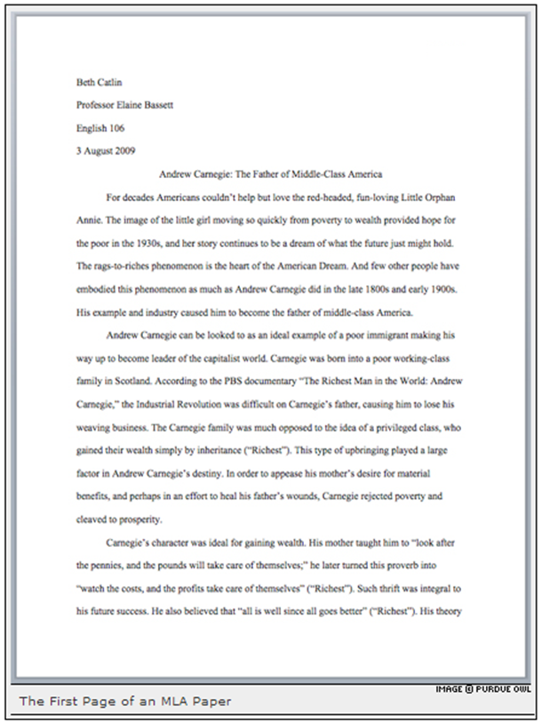

RESEARCH PRESENTATION

My Presentation Day is:___________________________

Rubric for Presentation of Paper

Presentation is between 10-12 minutes- 10 points
Presentation is engaging (audience interaction) and informative for the audience (research question, thesis, findings). The speaker demonstrates a deep understanding of the subject matter - 20 points
The speaker uses appropriate visual aids- 10 points
The speaker’s presentation is thououghly organized and prepared- 10

